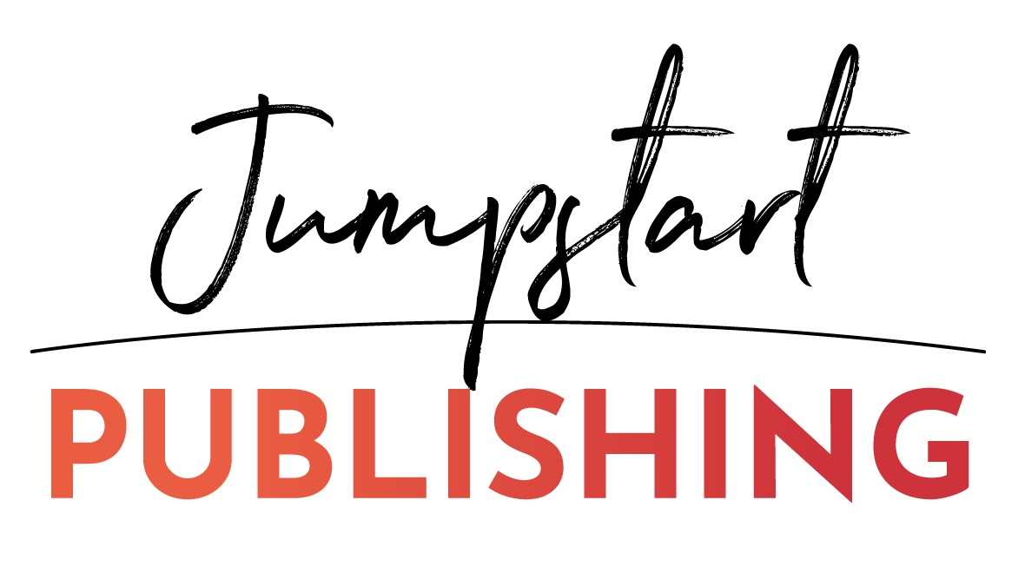

Instructions on building your supporter list
(and Template Email to Send)

Ok so now you want to build a list of people who will not just buy the book on launch day but who will share it too. I suggest you work on getting a list of people that will do this, put a spreadsheet together or list with their name, email and maybe cell for text reminders on launch day and/or their social profiles if those are better ways to get in touch with them.

Tell them now that you’ll be sending them an email/message with links and marketing copy as soon as we have them ready. They will most likely get it all within one week of the launch, sometimes it’s more last minute so they’ll have to be ready to copy and paste in the emails, social posts, etc. and schedule to send on launch day. The email below describes this. Basically, YOU can send this to THEM now to start building this supporter list.

As you are building your supporter lists for those who will market the launch on your behalf, not just share your posts... remember to look for people and friends/connections that you have outside the US too. I have a video tutorial that I’ve done to show you how to search on Facebook for those friends you may have outside the US here: https://youtu.be/-1owRwf7Ww8.
Below is a list of territories included in each Kindle Store:
- US Kindle Store: United States
- UK Kindle Store: United Kingdom (including Guernsey, Isle of Man, Ireland, Gibraltar, and Jersey)
- DE Kindle Store: Austria, Germany, Liechtenstein, Luxembourg, and Switzerland
- FR Kindle Store: France, Monaco, Belgium, Switzerland, and Luxembourg
- ES Kindle Store: Andorra, Spain
- IT Kindle Store: Italy, San Marino, Vatican City, and Switzerland
- JP Kindle Store: Japan
- NL Kindle Store: Netherlands
- BR Kindle Store: Brazil
- MX Kindle Store: Mexico
- CA Kindle Store: Canada
- IN Kindle Store: India
- AU Kindle Store: Australia, New Zealand

Here’s an email I wrote for you to send to friends/family/colleagues, you can edit to make it fit you more if you want but you want to keep this email simple, not too much detail about the book unless it’s below in the PS or below your signature for those who want to read more… Basically, you want to put the back cover copy there or a couple short paragraphs.
(The following is an email you can send or private message on social media too. The words in green need altering to YOUR specific situation or book – this is a template.) Note: this is NOT marketing copy for you to share on launch day!

Subject: I have a favor to ask you
Hi <firstname>,
As you've probably seen (or In case you haven’t seen), my next/first book, Stepping Into Gratitude, is launching soon... I’m excited to get this book out to help individuals learn how to practice gratitude on a more consistent basis… I’ve shared more about the book below but I’m reaching out today to ask you a BIG FAVOR...
I'm hoping to reach International Best-Seller status on Amazon on launch day which is June 18, 2024. The launch happens actually over a couple days, June 17 is the day we need people outside the US to buy since the different time zones and all. The 18th is the main day. Then on 19th and 20th there are always stragglers, so we try to continue pushing through a couple days following if we’ve not already made it to #1.
Since it’s my next/first book, I’m reaching for the stars, and I would love to get to #1 in multiple countries and I could really use your support.
YOUR SUPPORT could be in one or all 3 of the following ways:
- You can buy the eBook version on launch day, that would be great! I will be sending details out with links on where and how to buy on that day. I especially need anyone OUTSIDE the US to buy so we can get to #1 in many countries. The eBook will be on sale for $0.99. This makes it easier to get more buyers on launch day.
- Most importantly however, is IF YOU CAN ALSO SHARE THE BOOK OUT on launch day. Meaning, send an email to your friends or subscribers that day on our/my behalf or post on all your social media profiles and pages. I would give you marketing copy to use and all the links in case you have people following you that live outside the US. This helps us get in front of a LOT more eyeballs and most people are willing to help out book launches whether they know the author or not.
- Then once you buy the eBook yourself, writing a review on Amazon helps too. I can give you an advance PDF copy of the book now to read or review now so all you have to do closer to launch day is copy and paste into the Amazon review section.
What do you think?
Please respond with which way you’re able to support us in this launch!
Thank you so much in advance!
your full signature

PS - More about the book:

Insert back cover copy here or max two paragraphs so they know what the book is about and/or if there are multiple authors.

© Copyright 2025 Jumpstart Publishing and Katrina Sawa www.JumpstartPublishing.net

