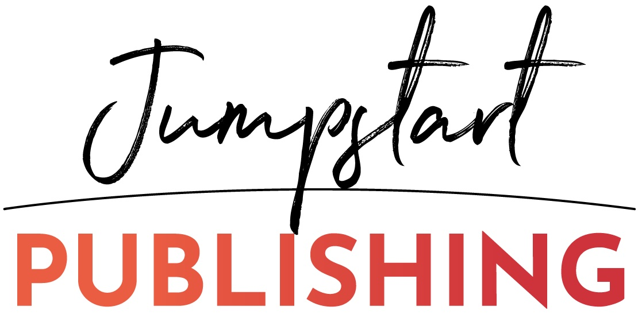

Putting together your manuscript

What else do you want or need to put inside your book besides the actual content itself?

Here’s a list of things that I help add in for you when you’re done with the manuscript. We can talk about which back-end pages would be good but the more the better, I say – It’s your book, you can promote yourself if you want!

- The inside Title page
- The copyright page – I have plenty of examples
- Do you want an acknowledgements or dedication page?
- Introduction
- Table of Contents
- What’s next chapter or page at the end – that’s the call to action, what do you want them to do next?
- Resources or Index pages if necessary?
- Any praise yet for the book or similar services you can add? meaning testimonials? We can add them into the front or the back.
- About the Author – this should be more than a paragraph. I recommend writing whatever and everything that you can think of. Write your official bio if you want in 3rd person or a personal note from the author in 1st person. Talk about your family, your journey, your lessons and what you’re doing now to help who.
- About the author page might roll right into “how to work with me” page where you talk about your ideal client, a couple ways you work with people, give an offer perhaps or drive to a 1on1 consult.
- Then there’s other back end sales pages that you want (optional), I can ‘design them’ to flow
  - Book you to speak, speaker page for you?
  - buy book in bulk page?
  - free gift page?
  - live event page?
  - Program or membership page?
  - other books you have page?

